

# 

### Semester One Examination, 2019

### Question/Answer booklet

# MATHEMATICS

**APPLICATIONS**

**UNIT 3**

## Section Two:

## Calculator-assumed

**NAME**

**TEACHER**

## Time allowed for this section

Reading time before commencing work: ten minutes

Working time: one hundred minutes

## Materials required/recommended for this section

***To be provided by the supervisor***

This Question/Answer booklet

Formula sheet (retained from Section One)

***To be provided by the candidate***

Standard items: pens (blue/black preferred), pencils (including coloured), sharpener,  
correction fluid/tape, eraser, ruler, highlighters

Special items: drawing instruments, templates, notes on two unfolded sheets of A4 paper, and up to three calculators approved for use in this examination

## Important note to candidates

No other items may be taken into the examination room. It is **your** responsibility to ensure that you do not have any unauthorised material. If you have any unauthorised material with you, hand it to the supervisor **before** reading any further.

## Structure of this paper

|  |  |  |  |  |  |
| --- | --- | --- | --- | --- | --- |
| Section | Number of questions available | Number of questions to be answered | Working  time (minutes) | Marks available | Percentage of examination |
| Section One:  Calculator-free | 8 | 8 | 50 | 52 | 35 |
| Section Two:  Calculator-assumed | 13 | 13 | 100 | 98 | 65 |
|  | | |  | **Total** | 100 |

|  |  |  |
| --- | --- | --- |
| Markers use only | | |
| Question | Maximum | Mark |
| 9 | 6 |  |
| 10 | 8 |  |
| 11 | 7 |  |
| 12 | 7 |  |
| 13 | 8 |  |
| 14 | 11 |  |
| 15 | 7 |  |
| 16 | 9 |  |
| 17 | 6 |  |
| 18 | 7 |  |
| 19 | 6 |  |
| 20 | 8 |  |
| 21 | 8 |  |
| S2 Total | 98 |  |
| S2 Wt (×0.6633) | 65% |  |

## Instructions to candidates

1. The rules for the conduct of examinations are detailed in the school handbook. Sitting this examination implies that you agree to abide by these rules.

2. Write your answers in this Question/Answer booklet preferably using a blue/black pen.  
Do not use erasable or gel pens.

3. You must be careful to confine your answer to the specific question asked and to follow any instructions that are specified to a particular question.

4. Show all your working clearly. Your working should be in sufficient detail to allow your answers to be checked readily and for marks to be awarded for reasoning. Incorrect answers given without supporting reasoning cannot be allocated any marks. For any question or part question worth more than two marks, valid working or justification is required to receive full marks. If you repeat any question, ensure that you cancel the answer you do not wish to have marked.

5. It is recommended that you do not use pencil, except in diagrams.

6. Supplementary pages for planning/continuing your answers to questions are provided at the end of this Question/Answer booklet. If you use these pages to continue an answer, indicate at the original answer where the answer is continued, i.e. give the page number.

7. The Formula sheet is not to be handed in with your Question/Answer booklet.

Section Two: Calculator-assumed 65% (98 Marks)

This section has**thirteen (****13)** questions. Answer **all** questions. Write your answers in the spaces provided.

Working time: 100 minutes.

Question 9 (6 marks)

(a) In a group of five people it was known that Kai was older than Lily, Nat and Jen; Mike was older than Kai and Lily; Nat was older than Jen; and Lily was older than Nat.

(i) Represent this set of age relationships as a digraph. (2 marks)

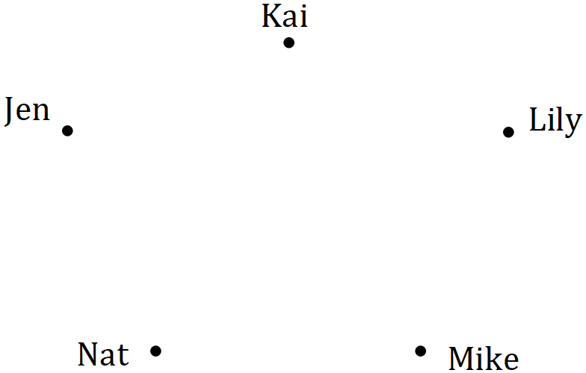

(ii) State the number of arcs in the digraph. (1 mark)

(iii) List the five people in order of age, starting with the youngest. (1 mark)

(b) Graph $H$ is shown below.

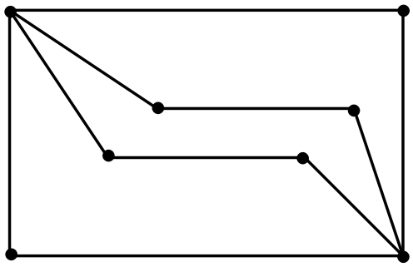

Let $t$ and $p$ be the number of edges in the longest open trail and shortest closed path contained in $H$ respectively. State the values of $t$ and $p$, given that $t>0$ and $p>0$.

(2 marks)

Question 10 (8 marks)

The following data shows the blood haemoglobin ($H$) levels and packed cell volumes ($V$) of $10$ blood bank donors.

|  |  |  |  |  |  |  |  |  |  |  |
| --- | --- | --- | --- | --- | --- | --- | --- | --- | --- | --- |
| $$H$$ | $$15.5$$ | $$13.6$$ | $$13.8$$ | $$12.9$$ | $$12.5$$ | $$12.3$$ | $$14.8$$ | $$13.1$$ | $$16.1$$ | $$16.4$$ |
| $$V$$ | $$0.45$$ | $$0.42$$ | $$0.44$$ | $$0.42$$ | $$0.41$$ | $$0.39$$ | $$0.43$$ | $$0.41$$ | $$0.45$$ | $$0.47$$ |

(a) Graph the data on your calculator and describe features of the graph that suggest the presence of a strong and positive linear association between $H$ and $V$. (2 marks)

(b) Determine the equation of the least-squares line that models the relationship between $H$ and $V$, where $H$ is the explanatory variable. (2 marks)

(c) Calculate the correlation coefficient between $H$ and $V$. (1 mark)

(d) What percentage of the variation in $V$ can be explained by the variation in $H$? (1 mark)

(e) Predict the packed cell volume of a donor with a blood haemoglobin level of $13.5$. (1 mark)

(f) Describe a potential danger associated with using the least-squares line to predict a packed cell volume from a blood haemoglobin level. (1 mark)

Question 11 (7 marks)

A company bought and installed a new computer system with an initial value of $\$29 400$. For accounting purposes, the value of the system decreased by $\$2 450$ each year.

(a) Calculate the value of the system after $3$ years. (1 mark)

(b) Determine a recurrence relation for $V_{n}$, the value of the system after $n$ years. (2 marks)

(c) Determine

(i) the value of the system after $7$ years. (1 mark)

(ii) the number of years for the value of the system to become nothing. (1 mark)

(d) Determine the additional time taken for the system to become worthless if its value decreased by $\$1 470$ each year instead of $\$2 450$. (2 marks)

Question 12 (7 marks)

The scatterplot below shows the marks scored by $30$ students in their theory ($t$) and practical ($p$) exams that were marked out of $60$ and $90$ marks respectively.

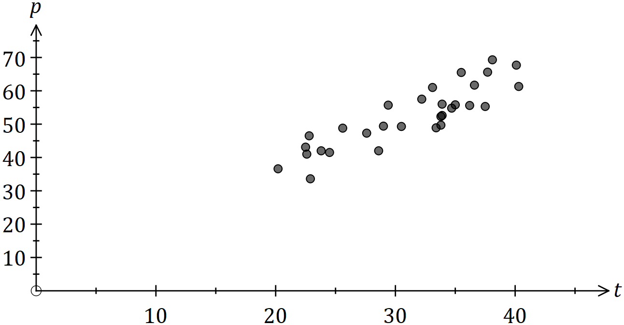

The equation of the least-squares line for the data is $p=1.38t+9.2$.

(a) It was found that $77\%$ of the variation in $p$ could be explained by the variation in $t$. Determine the correlation coefficient $r_{tp}$. (1 mark)

(b) Interpret the slope of the least-squares line. (2 marks)

(c) Joe and Kai were absent for the practical exam, but it was known that their marks in the theory exam were $28$ and $57$ respectively. Predict their practical exam marks and explain how reliable each prediction is. (4 marks)

Question 13 (8 marks)

A builder has quotes from four electricians ($E$) to carry out repairs at four properties ($P$). The quotes are in dollars and not all electricians quoted for all properties, as shown in the table below.

|  |  |  |  |  |
| --- | --- | --- | --- | --- |
| $$(\$)$$ | $$P_{1}$$ | $$P_{2}$$ | $$P_{3}$$ | $$P_{4}$$ |
| $$E_{1}$$ | $$250$$ | $$-$$ | $$480$$ | $$380$$ |
| $$E_{2}$$ | $$-$$ | $$880$$ | $$510$$ | $$-$$ |
| $$E_{3}$$ | $$260$$ | $$-$$ | $$-$$ | $$375$$ |
| $$E_{4}$$ | $$-$$ | $$725$$ | $$-$$ | $$-$$ |

(a) Draw a weighted bipartite graph to represent this information. (4 marks)

The builder decides to give all the electricians one property each to repair.

(b) Calculate the total cost to repair all four properties if $E_{3}$ repaired $P_{1}$. (2 marks)

(c) Determine the minimum total repair cost and the allocation of electricians to achieve this minimum. (2 marks)

Question 14 (11 marks)

A researcher obtained the following data whilst investigating whether it is possible to reliably predict a child's reading ability ($A$, on a numerical scale of $1$ to $25$) from their hand span ($H$, cm).

|  |  |  |  |  |  |  |  |  |  |  |  |  |
| --- | --- | --- | --- | --- | --- | --- | --- | --- | --- | --- | --- | --- |
| Child | B | C | D | E | F | G | J | K | L | M | N | P |
| $$H$$ | $$11.5$$ | $$12.5$$ | $$16.5$$ | $$15.0$$ | $$14.0$$ | $$13.5$$ | $$12.0$$ | $$13.0$$ | $$17.0$$ | $$15.5$$ | $$14.5$$ | $$12.0$$ |
| $$A$$ | $$10$$ | $$12$$ | $$17$$ | $$15$$ | $$14$$ | $$11$$ | $$11$$ | $$10$$ | $$15$$ | $$14$$ | $$16$$ | $$10$$ |

(a) State the response variable for this investigation. (1 mark)

(b) Add the three missing data points to the scatterplot below. (2 marks)

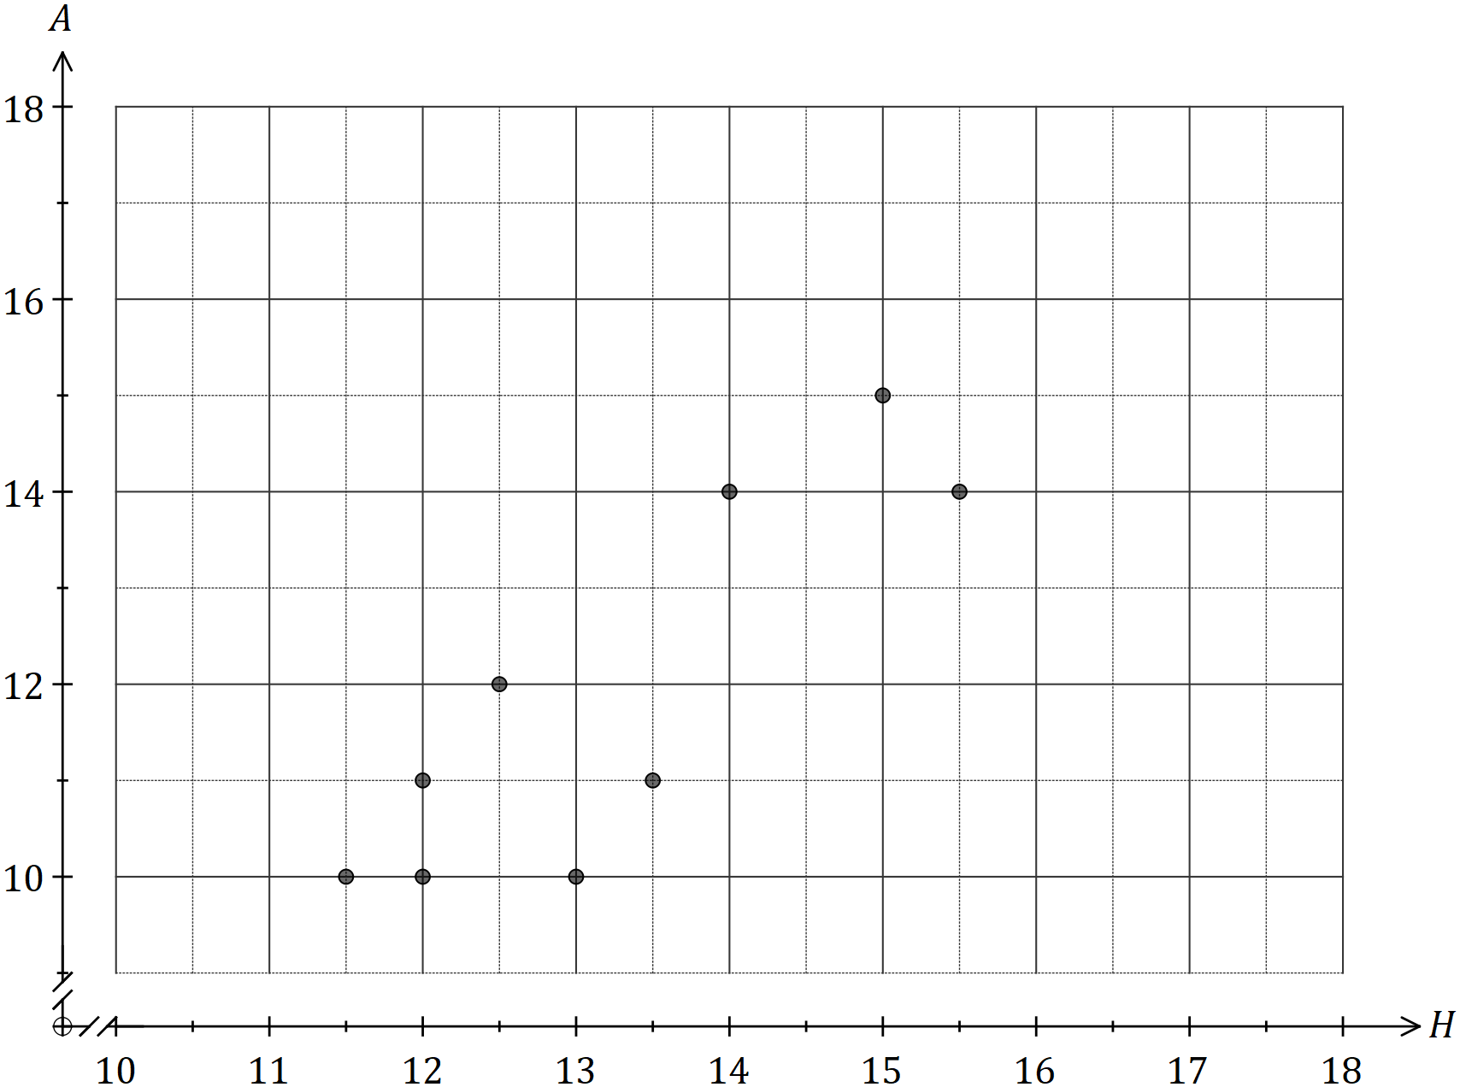

(c) Determine the correlation coefficient between the two variables. (1 mark)

(d) Using the scatterplot from (b) and the correlation coefficient from (c), the researcher was satisfied that a linear association existed between $A$ and $H$. Explain why they reached this conclusion. (2 marks)

The researcher then discovered that the children labelled B, C, G, J, K and P were all in Year 4 and the remainder in Year 7.

(e) Circle the Year 4 children on the graph. (1 mark)

(f) Calculate the correlation coefficient between $A$ and $H$ for the Year 4 children only.

(1 mark)

(g) Identify a non-causal explanation for the conclusion reached by the researcher in (d) and explain how this new information (f) affects that conclusion. (3 marks)

Question 15 (7 marks)

A water tank is initially empty. At the start of each hour, $120$ L of water is quickly poured into the tank but during the following hour, $15\%$ of all the water in the tank leaks out.

This situation can be modelled by the recurrence relation $V_{n+1}=0.85V_{n}+120, V_{0}=120$, where $V_{n}$ is the volume of water in the tank, in litres, at the start of the $n^{th}$ hour.

(a) Complete the table below, giving volumes to the nearest litre. (2 marks)

|  |  |  |  |  |  |
| --- | --- | --- | --- | --- | --- |
| $$n$$ | $$0$$ | $$5$$ | $$10$$ | $$15$$ | $$20$$ |
| $$V_{n}$$ |  |  |  |  | $$774$$ |

(b) At the start of which hour does the tank first hold at least $798$ L? (1 mark)

(c) Plot the points from the table on the axes below. (2 marks)

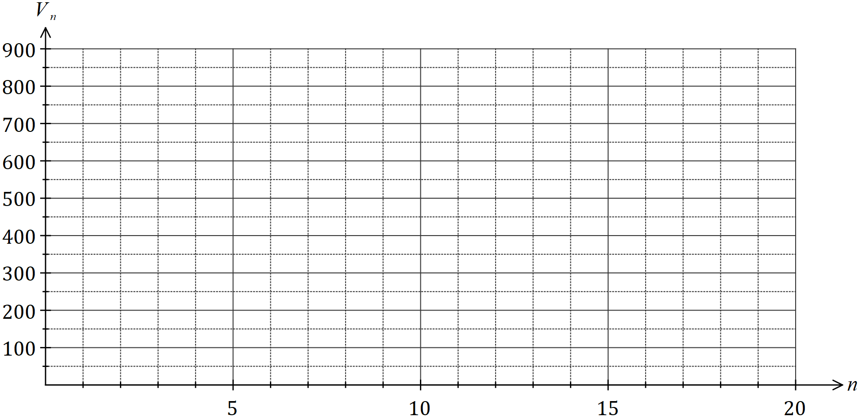

(d) The tank has a maximum capacity of $850$ L. If possible, determine the least number of hours since filling commenced that the tank will start to overflow. If not possible, explain why not. (2 marks)

Question 16 (9 marks)

A study categorized the weight of hospitalised children as underweight, normal, overweight or obese. The numbers of children in each category are shown by gender in the table below.

|  |  |  |  |  |
| --- | --- | --- | --- | --- |
|  | Underweight | Normal | Overweight | Obese |
| Female | $$30$$ | $$195$$ | $$52$$ | $$29$$ |
| Male | $$12$$ | $$174$$ | $$81$$ | $$17$$ |

(a) An obese child is randomly chosen from the study. If possible, explain whether they are more likely to be a boy or a girl. If not possible, explain your reasoning. (2 marks)

(b) What percentage of the boys in the study were classified as underweight? (2 marks)

(c) Complete the table of **row** percentages below to the nearest whole number. (3 marks)

|  |  |  |  |  |
| --- | --- | --- | --- | --- |
| (%) | Underweight | Normal | Overweight | Obese |
| Female | $$10$$ |  |  |  |
| Male |  |  |  | $$6$$ |

(d) Does the table of row percentages suggest the presence of an association between the categorical variables? Justify your answer. (2 marks)

Question 17 (6 marks)

A piledriver is hammering a pile into the ground. The graph below shows the distance $T_{n}$ (in cm) the pile moves into the ground on the $n^{th}$ hit of the piledriver.

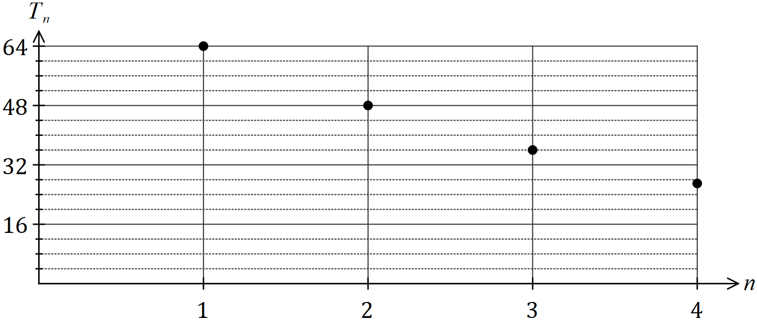

The values of $T_{n}$ form a geometric sequence.

(a) Use information from the graph to determine the common ratio for the sequence. (1 mark)

(b) Write a recurrence relation to generate the values of $T_{n}$. (2 marks)

(c) Write the $n^{th}$ term rule for the values of $T_{n}$. (1 mark)

(d) Determine

(i) the distance the pile moves into the ground on the tenth hit of the piledriver.

(1 mark)

(ii) on which hit the pile first moves less than one mm into the ground. (1 mark)

Question 18 (7 marks)

Each vertex on the graph below represents an airport and an edge between two airports indicates that an airline has a direct flight, in both directions, between the airports.

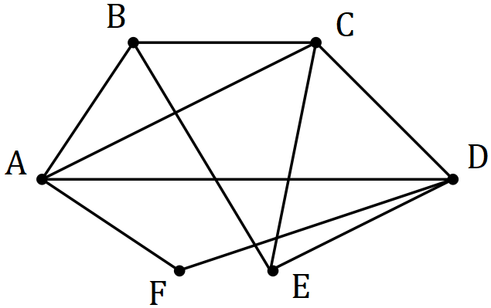

(a) Redraw the graph to clearly show that it is planar. (1 mark)

(b) Demonstrate that the graph satisfies Euler's formula. (2 marks)

In order to check in-flight catering quality, an airline manager plans to leave airport $A$, travel on at least one flight between the $10$ pairs of airports and then return to $A$. The manager does not use any other mode of transport between airports.

(c) Determine the minimum number of flights the manager must take and list, in order, the airports visited. (2 marks)

(d) Another manager, based at a different airport, claimed they could carry out the quality check in fewer flights by starting and finishing at their airport. Comment on this claim.

(2 marks)

Question 19 (6 marks)

A statistician wants to check whether a linear model is appropriate for a bivariate data set they are analysing. The least-squares line to model the linear relationship is $y=2.09x+8.88$ and the correlation coefficient between the variables is very strong.

The residual plot using the linear model is shown below for all but two of the data points.

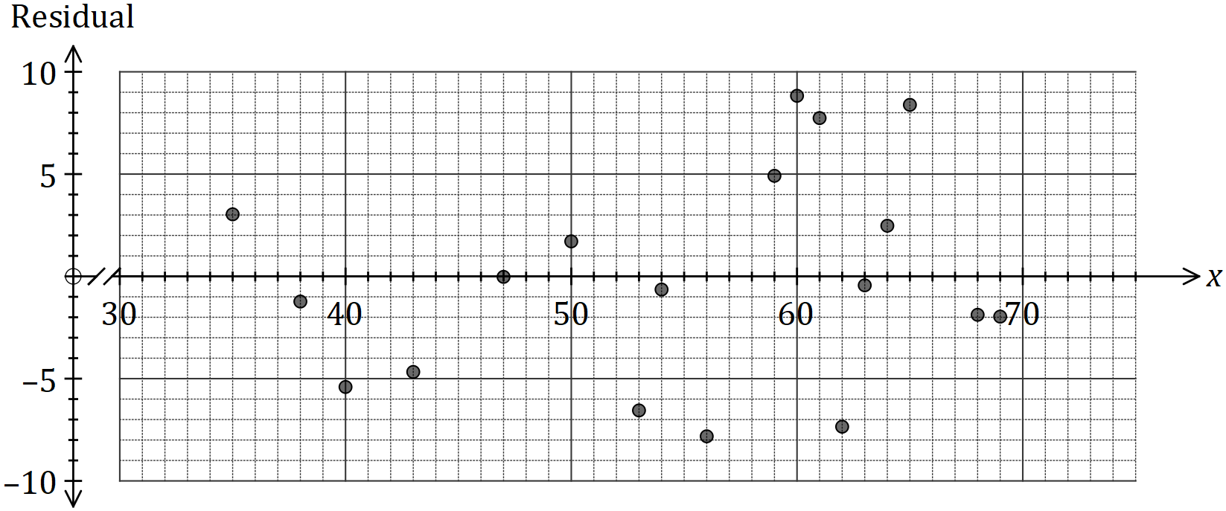

(a) Calculate the residuals for the missing points $(45, 111)$ and $(72, 152)$ and plot them on the graph above. (4 marks)

(b) Use the residual plot to explain whether fitting a linear model to the data is appropriate.

(2 marks)

Question 20 (8 marks)

The vertices below represent $8$ computers in a network and the weights on each edge represent the time, in milliseconds, for a signal to be sent directly between connected computers.

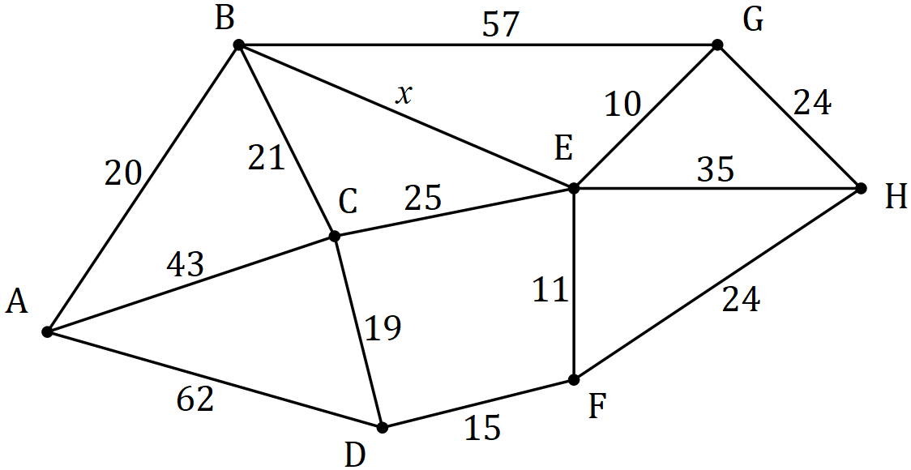

(a) Given that $x=48$, determine the path required and the time taken to send a signal in the least time between

(i) $B$ and $G$. (2 marks)

(ii) $A$ and $E$. (2 marks)

(iii) $A$ and $H$. (2 marks)

(b) Determine the largest value of $x$, to the nearest millisecond, to ensure that the fastest route to send a signal between $A$ and $H$ will pass through $E$. Justify your answer.

(2 marks)

Question 21 (8 marks)

(a) An investor has $\$540$ in an account. One month later, and at the start of each subsequent month, a deposit of $\$35$ is added to the account. Interest, calculated as $0.72\%$ of the balance at the start of the month, is added to the account just before each deposit is made.

The account balance after $n$ deposits is $T_{n}$, and can be modelled by the recurrence relation $T_{n+1}=1.0072T_{n}+35, T_{0}=540$.

(i) Determine the balance in the account after $4$ deposits have been made. (1 mark)

(ii) After how many deposits does the balance of the account first exceed $\$1 200$ and what is the balance of the account at that time. (2 marks)

(b) The investor also has $\$85$ in another account. One week later, and at the start of each subsequent week, a deposit of $\$5.75$ is added to the account. Interest, calculated as $0.095\%$ of the balance at the start of the week, is added to the account just before each deposit is made.

(i) Write a recurrence relation to model the balance of this account after $n$ deposits.

(3 marks)

(ii) Determine the balance in this account after $40$ deposits have been made. (1 mark)

(iii) By considering the total deposits made, or otherwise, determine the total interest added to this account after $40$ deposits have been made. (1 mark)

Supplementary page

Question number: _________

Supplementary page

Question number: _________

Supplementary page

Question number: _________

© 2019 WA Exam Papers. Kennedy Baptist College has a non-exclusive licence to copy and communicate this document for non-commercial, educational use within the school. No other copying, communication or use is permitted without the express written permission of WA Exam Papers. SN245-136-3.